**VAISHALI BOKADIYA**

**AZURE DATABRICKS**

**CODING ASSESSMENT**

**QUESTION 2**

**Question 2**

**Explain Overview of 3 level namespace and creating Unity Catalog objects.**

The three level namespace includes:

1. Catalog
2. Schema
3. Tables

**Catalog**

It is the first layer of the namespace. It is used to organize your data. Users can only view catalogs on which they have been given USE CATALOG data permissions.

**Schema**

It is the second layer of the namespace. It is also known as Database. This layer contains data in the form of tables and views.

**Tables**

It is the third layer of the namespace. It contains rows of data. User must have CREATE and USE SCHEMA data permissions to create the table.

**Unity Catalog**

Unity Catalog is a unified solution for governance of data and AI assets on Databricks.

It provides centralized access control, auditing and lineage to Databricks Workspaces. It also provides data discovery capabilities in Databricks Workspaces.

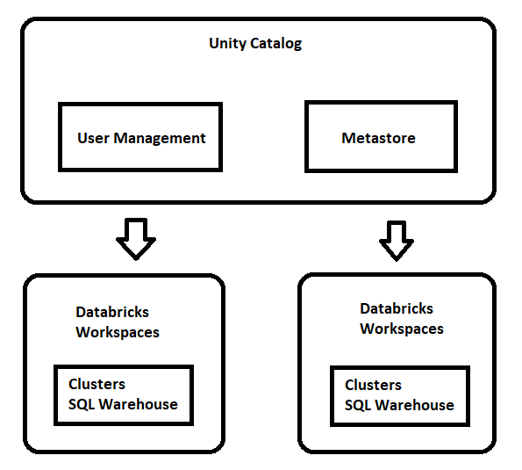

The unity catalog object model contains:

1. Metastore
2. Catalog
3. Schema
4. Tables, views, and volume
5. Models

**Meta store**

It is the topmost level container for metadata. Each container has three level namespace to organise the data.

**Catalog**

It is the first layer of the namespace. It is used to organize your data.

**Schema**

It is the second layer of the namespace. It is also known as Database. This layer contains data in the form of tables and views.

**Tables**

It is the third layer of the namespace. It contains rows of data.

**Models**

It is the lowest level in the hierarchy.